

|  |  |
| --- | --- |
| **Project Title: Online Ordering Mobile Application** |  |
| **Staffordshire University**  **BSc (Hons) Computer Science**  **Final Year Project Interim Report**  **Course: 153-29010**  **Project Supervisor: Samson Ng**  **Prepared by: Ng Ka Chon**  **Student ID: 53161847**  **Proposal submission date: 03/10/2016** |  |

Contents

[1 Background 4](#_Toc468049497)

[2 Problem Identification 5](#_Toc468049498)

[3 Scope 7](#_Toc468049499)

[4 Objectives 7](#_Toc468049500)

[5 Critical Success Factor 8](#_Toc468049501)

[6 Investigation 9](#_Toc468049502)

[6.1 Questionnaire 9](#_Toc468049503)

[6.2 SWOT 17](#_Toc468049504)

[6.2.1 Strengths 17](#_Toc468049505)

[6.2.2 Weaknesses 18](#_Toc468049506)

[6.2.3 Opportunities 18](#_Toc468049507)

[6.2.4 Threats 18](#_Toc468049508)

[6.3 Case Studies 19](#_Toc468049509)

[6.3.1 foodpanda 19](#_Toc468049510)

[6.3.1.1 Introduction 19](#_Toc468049511)

[6.3.1.2 Operation 20](#_Toc468049512)

[6.3.1.3 Good and Bad 24](#_Toc468049513)

[6.3.2 UberEats 25](#_Toc468049514)

[6.3.2.1 Introduction 25](#_Toc468049515)

[6.3.2.2 Operation 26](#_Toc468049516)

[6.3.2.3 Good and Bad 30](#_Toc468049517)

[4 Development Methodologies Consideration 31](#_Toc468049518)

[4.1 Structured systems analysis and design method 31](#_Toc468049519)

[4.2 Incremental 32](#_Toc468049520)

[4.3 Rapid Application Development 33](#_Toc468049521)

[4.4 Methodology Selected 34](#_Toc468049522)

[5 Project Plan 35](#_Toc468049523)

[5.1 Project Schedule 35](#_Toc468049524)

[5.2 Work Break Down structure 36](#_Toc468049525)

[5.3 Gantt Chart 37](#_Toc468049526)

[5.4 Project Deliverables 38](#_Toc468049527)

[5.5 Development Tools 39](#_Toc468049528)

[6 Reference 40](#_Toc468049529)

# Background

Eating is one of the most important part of our lives and most of us, as we ate around 3 to 4 meals a day. Science cooking is not a skill that most people are proficient at and people usually want to eat at their own place, food delivering service in very popular in the Hong Kong. Although most of the restaurant in Hong Kong provide food delivering service, they usually do not implement an electronic system to handle orders. It is time-consuming, easy to make mistake and not convenience. Instead most of the restaurant still rely on phone call to handle orders.

There is a famous mobile application for find restoration called “OpenRice” [1] but does not provide food ordering services. “Takeaway.com - Order Food” [2] do provide food order services which allow user to order food online with their mobile devices and allow online payment using credit card and PayPal but it's main business wasn’t based in Hong Kong. “Foodpanda”, meanwhile, do provide food order services in Hong Kong but it does not provide as much restaurants as “OpenRice” did.

The main aim of this project is to develop an online ordering system for restaurants in Hong Kong to improve the efficiency and accuracy of food ordering service and reduce the words needed for user to find restaurant that provide food delivery service.

# Problem Identification

* Inefficient Order Handling

The order handling the process of the most restaurant in Hong Kong usually involve a restaurant’s staff who wait for phone calls and after he/she received a phone call, he/she then pass the order information to the kitchen and prepare the dishes for delivery. The process is inefficient and error-prone and this process can be automated by using a computer application.

* Printed Manual

The major problem of the current food ordering process is that a printed manual is needed for the contact information as well as the food that can be ordered since most of the restaurant in Hong Kong do not have their own web-site for storing this kind of information. In addition, the customer must keep the printed manual for ordering foods which are very inconvenient. There are also other disadvantages when using the current approach including printed manual are easily out-of-date. Also, whenever restaurant's staff want to make changes to the menu, they need to print another set of menu and give it to their customers. Customers who never visits the restaurant physically will not get the latest version of the menu which makes it difficult to update their menu. Using printed menu is difficult for the restaurant to attract new customer and not environmental friendly.

* Difficult to discover new restaurant/attract new customers

People's appetite change from time to time and peter like to try new food all the time. Currently, discover a new restaurant which provides food delivering service around their places require online researching, asking friends and family and walking around different places. It would be time-consuming for the customer to discover a new restaurant and it would be so much better if there is an application that could provide find out all the nearby restaurant and provide notification when there is a new restaurant opened.

* Difficult to combine multiple orders into a single order

Let’s say if a department head wants to buy lunch for all the team members in his/her department, usually in this kind of situation, a printed manual of a specific restaurant will be passed around each team member for viewing and deciding what kind of food they want. Then a member of the team will collect all the orders from different member and start ordering with a phone call. Although this is not a very complicated task, it wasted a lot of time before everyone can get their meal.

* Lack of food customization option

Today's consumer is more educated and knows that nutrition is an important part of their life. They care about how their foods were made and what goes into it. Some of the consumers might want their food to have less salt and sugar and other requirements (e.g. vegetarians) might want to remove cheese from their food or make it very spicy. Customization is a new food services trend and currently the existing ordering platform does not provide customization.

# Scope

1. Build a mobile application to allow user order food from a restaurant.
2. Implement registration process for the mobile application which allows user to create account with their Google+ account and Facebook account.
3. Implement a search function which searches nearby restaurant which provides food delivering service base on their current location.
4. Implement a function which allows users to view their transaction history.
5. Implement a function which allows merge orders from different users.
6. Build a desktop application to allow restaurant’s staff to view the current orders.
7. Implement a function which allows restaurant’s staff to add/remove items from the online menu.
8. Add a reporting function which allows restaurant’s management staff to view transaction history.
9. Implement login feature for the desktop application to enforce security.

# Objectives

1. Provide a tool for user to search different restaurant which provide food delivering services around them.
2. Provide an intermediate platform for customer and restaurant to create and accept orders.
3. Provide a tool for restaurant to create and maintain an online menu of theirs.
4. Enabling restaurant’s staff to handle orders more efficiently and accurately.
5. Omit the need of keeping a printed menu for ordering food.

# Critical Success Factor

* The project can be completed on schedule.
* The functional and user acceptance tests are passed.
* The server can handle client requests stably and without performance issues.
* The reporting system can provide comprehensive and accurate information about the ordering data.
* The procedure in the contingency play can quickly resume the system within an hour.
* The project document is accurate and consistent.

# Investigation

# Questionnaire

Questionnaire is used in this investigation. The main purpose of this questionnaire is to find how people feel about online food ordering services and understand what factors are affecting them on ordering food.

The questionnaire is conducted on 10th September, 2016 to 20th September, 2016 using Google Form. The questionnaires are mainly distributed to user through social media such as Facebook, twitter and forums. The questionnaire has seven multiple choses questions and none of them are optional. There are total 48 questionnaires answered and the result are shown and analyzed as following:

* + - 1. Do you own a smartphone?

1. Yes B. No

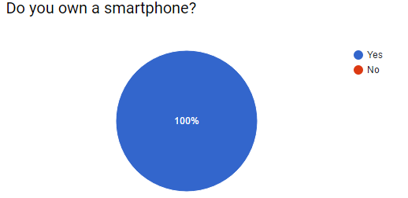

This question is used to identify how many people own a smartphone and according to the result, all the participant of this questionnaire own a smart phone. Therefore, there can be a lot of potential user for online ordering service application.

* + - 1. Have you ever shop online?

1. Yes B. No

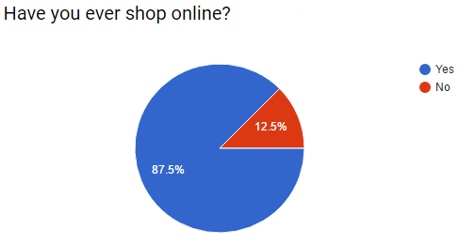

This question is used to know how many people had used online payment before. Almost ninety percent of the participant had shop online before and around ten percent of the participant did not had experiencing in online shopping. According to the result, we can safely assume that most of the user of this project are already familiar with online payment

* + - 1. How many times a week do you order food for carry out or delivery?

1. 0 B. 1-5 C. 5-10 D. 10-20 E. >20

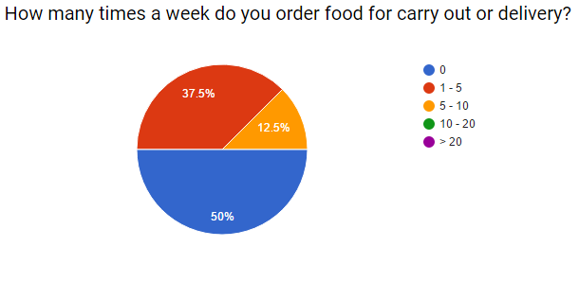

This question is used to identify how often do people order food for carry out or delivery. Half of the participant do no order food for carry out or delivery, almost 40 percent of participant do order food for carry out or delivery one to five times a week and around ten percent of participant order foods for carry out or delivery five to ten times a week. According to the result, half of the participant will not use online food ordering application since they do not order food for carry out or delivery and the other half might.

* + - 1. Which of the following method do you prefer for ordering food?

1. Telephone B. Restaurant Site C. Restaurant App D. Others

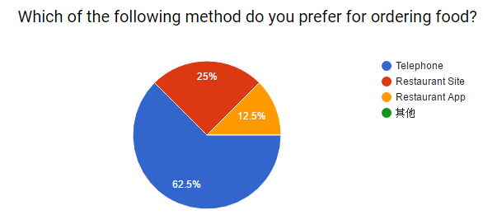

This question is used to identify which kinds of method people prefer to use when ordering food. Around sixty percent of participant prefer using telephone for ordering food, twenty-five percent of participant prefer using the restaurant site for ordering and around twelve percent of participant prefer using restaurant app for ordering. Even with existing online food ordering application, most of them still prefer using telephone over electronic devices for ordering food. This lead to another question and it is why people don’t use electronic devices for ordering food.

* + - 1. Do you think online food ordering is easy and convenient??

1. Yes B. No

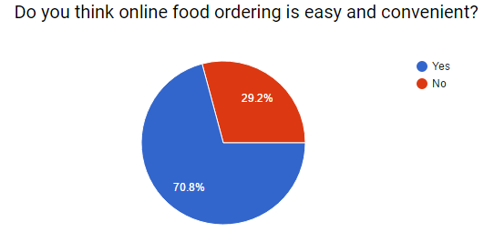

This question is used to know do people think online food ordering is easy and convenient. Around seventy percent of the participant thinks that online food ordering is convenient and around thirty percent of participant thinks the opposite. Majority of the participant thinks that online food ordering is easy and convenient, however majority of the participant do not use online food ordering. It indicates that there are some problems in the existing online food online system which lead to this result.

* + - 1. Do you own a smartphone?

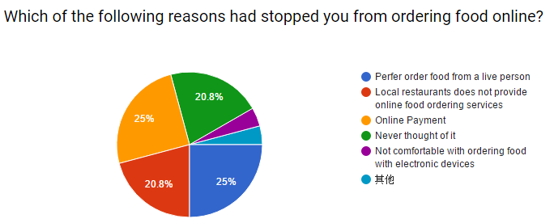A. Prefer order food from a live person

B. Local restaurants does not provide online food ordering services

C. Online Payment

D. Never thought of it

E. Not comfortable with ordering food with electronic devices

F. Other

This question is used to identify why people do not ordering food online. Twenty-five percent of participant prefer order food from a live person, another twenty-five percent of participant do no order food online because of online payment, around twenty percent of participant never thought of ordering food online and other twenty percent of participant do not order food online because the local restaurant does not provide online food ordering services. The above four reason can be addressed with the following method:

C: Provide cash on delivery function

B & D: Advertisement

* + - 1. What kind of payment method do you prefer for food ordering application?

1. Cash B. Credit Card C. EPS D. Octopus Card

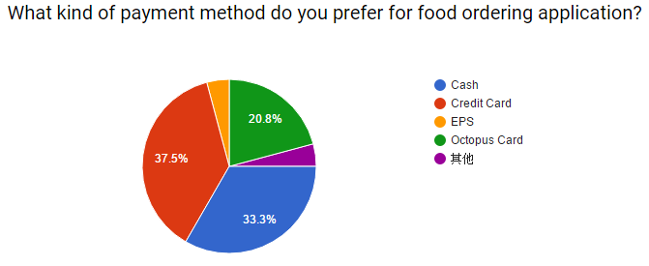

This question is used to identify which kinds of payment method people prefer when use food ordering application. Around forty percent of participant prefer using credit card, twenty percent of participant prefer using Octopus Card and around thirty-five percent of participant prefer using cash. Payment methods including cash, credit card and octopus card should be included in the online food ordering application.

# SWOT

SWOT analysis is an [acronym](https://en.wikipedia.org/wiki/Acronym#Nomenclature) for Strengths, Weaknesses, Opportunities and Threats. SWOT analysis is a structured method for identifying and evaluating those four elements. SWOT analysis is widely used approach for strategic planning [4] and it can be used on product or project. It helps to identify both internal and external factors that are good and bad for the product or project.

* Strengths: Factors that will help the business to gain comparative advantage over others
* Weaknesses: Factors that bring disadvantages to the business relative to others
* Opportunities: Chances which can be used by the company to improve the competitive position
* Threats: Factors in the business environment that may bring problems to the business

# Strengths

* Offers wide range of food from different restaurant
* Customer can customize their foods
* Provides most up to date menu
* Allows cash on deliver payment
* 24/7 availability

# Weaknesses

* Relay on restaurants themselves to provide delivery services
* Limited control in pricing
* Single platform (android)
* Limited funding
* Only accessible for customer with internet services

# Opportunities

* Young people do not prefer cooking
* Many local restaurants do not provide online food ordering services
* Increasing demand of food customization for healthy life style
* Major competitors only allow placing order after payment

# Threats

* Changes in regulation may impact the business
* Competitor may copy some of the system features
* Depends on network connectivity, network outage will lead to loss of sales

# Case Studies

In order to gain more insight on how online food ordering mobile application work, investigation on the similar application is a good way for doing so. By studying similar system, functions which are good or bad can be easily identified. In addition, identifying bad functions or features from existing system can help the project to avoid these mistakes.

Currently there are two well-known food ordering application in Hong Kong, which are “foodpanda” and “UberEats”.

# foodpanda

# Introduction



foodpanda is an international company which headquartered in Berlin, Germany. foodpanda provide online food ordering services in 43 countries and territories including Singapore, Taiwan, Hong Kong and many others.

foodpanda handles and sends orders directly to partner restaurants, after restaurants received the orders, they will then prepare the orders and deliver to the foodpanda user.

User can place order either via foodpanda website or using the foodpanda mobile application.

# Operation

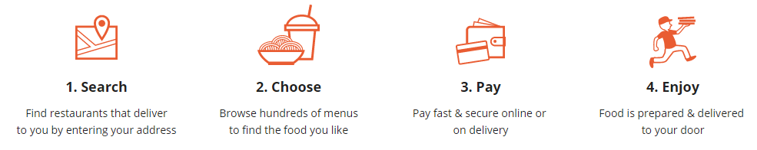

* + - 1. Search

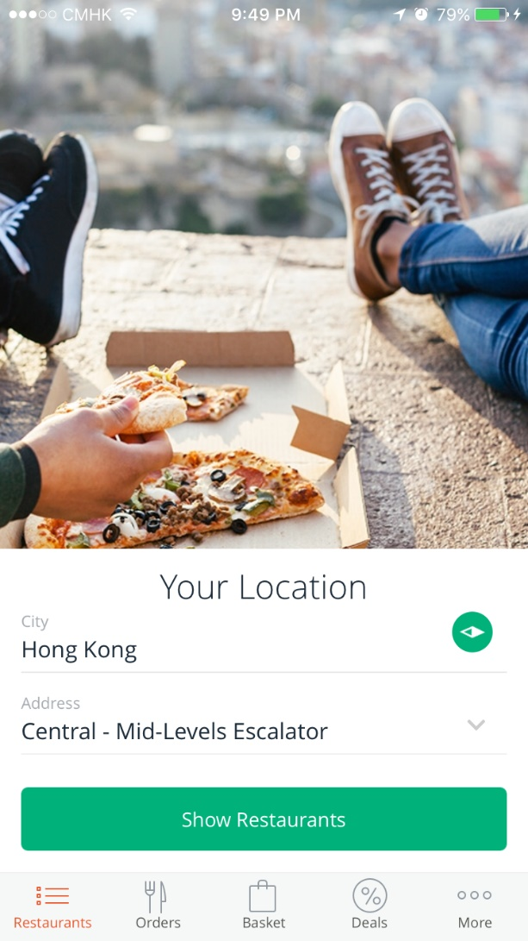After login to foodpanda, the first thing you need to do is to enter your current location. It can be done by use the phone’s GPS or enter it manually. After entering the location, clicking the “Show Restaurants” will lead to another page which show the nearby restaurants.

* + - 1. Choose

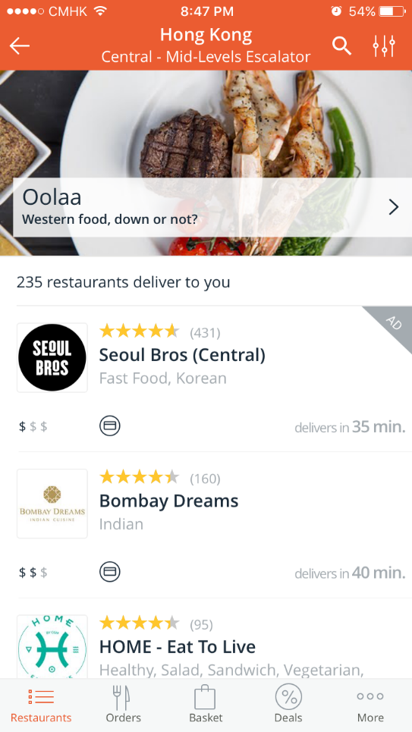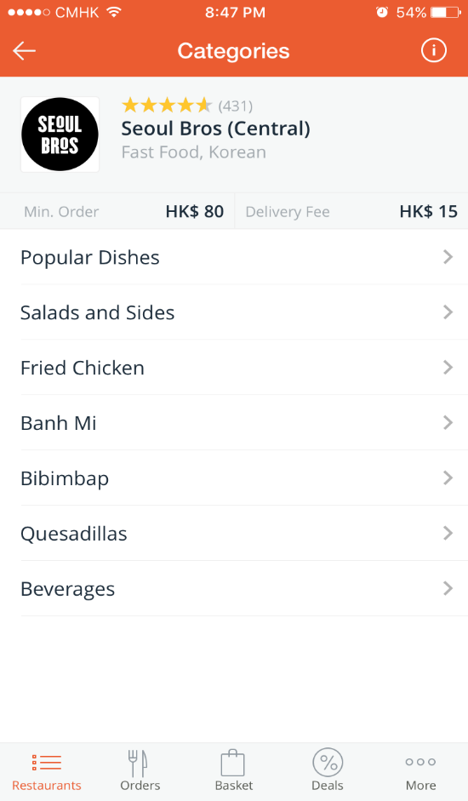

* Choosing Restaurant

In this page, you can browse different kind of restaurants. All the restaurants in this page is ordered by the delivers times and currently advertising restaurants will always on the top of the list if it is nearby. This page also show the rating of the restaurants and how expensive the food is under the restaurant’s logo. After selecting the restaurants, it will lead you to the menu.

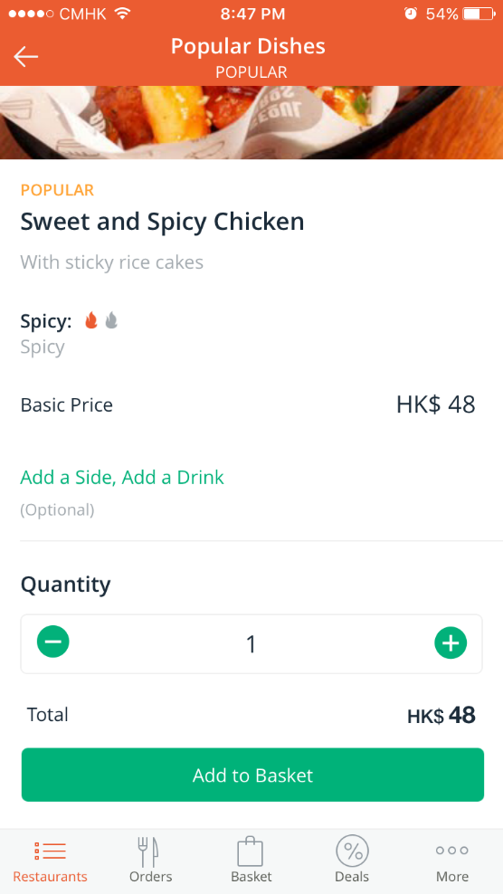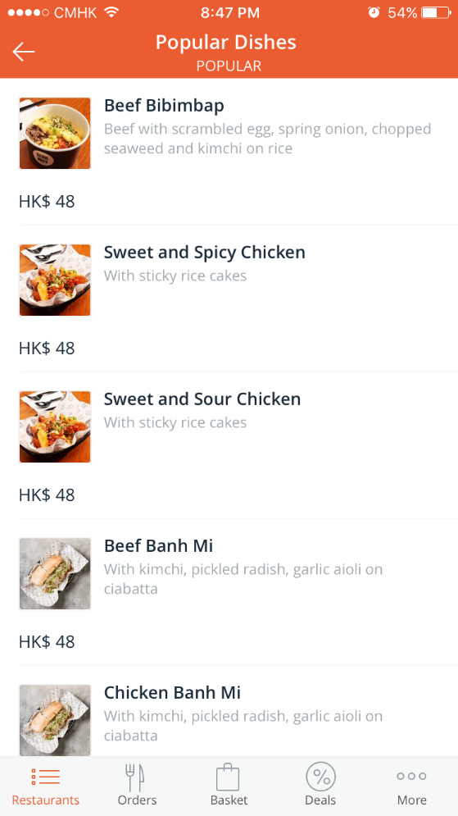

* Choosing Food

In this page, it shows all the foods which the selected restaurant provides. It contains a picture of the food, the name of the food, a brief description of the food and the price.

After selecting the food, it will bring you to another page which provide a bigger picture of the food. This page also allows you to add side and drink with the food you want to order. After deciding side and drink, there is a button at the bottom which allow you to add this order to the basket.

* 1. Payment

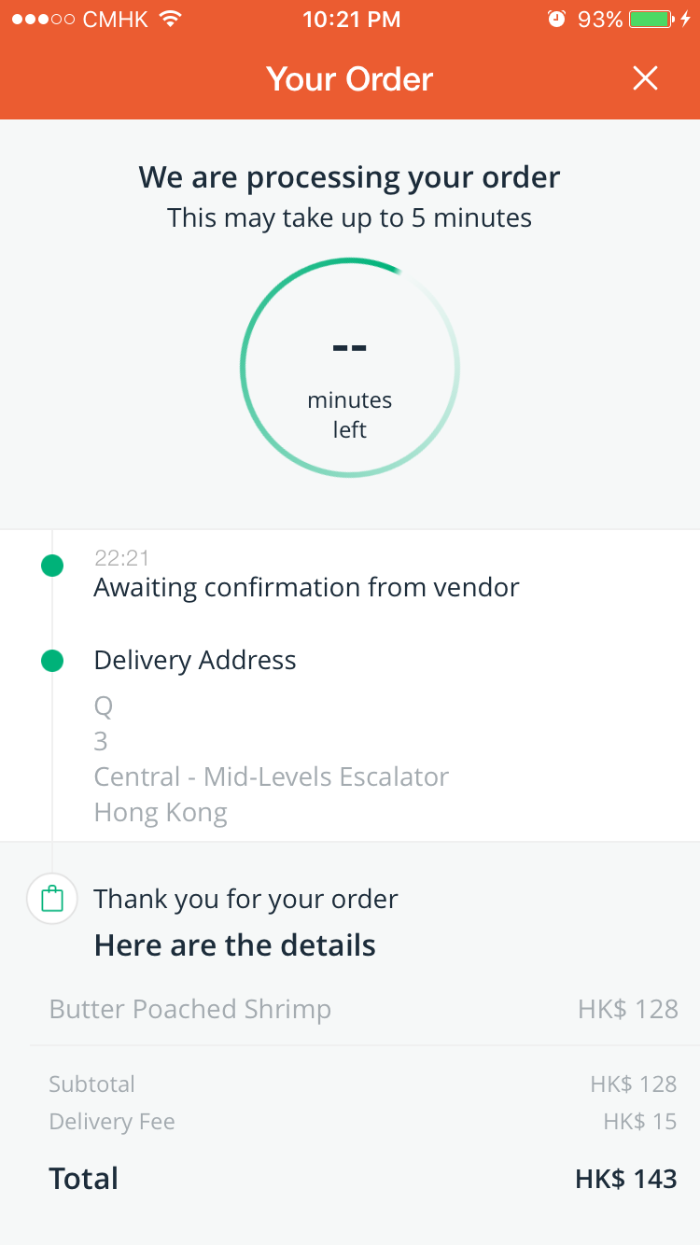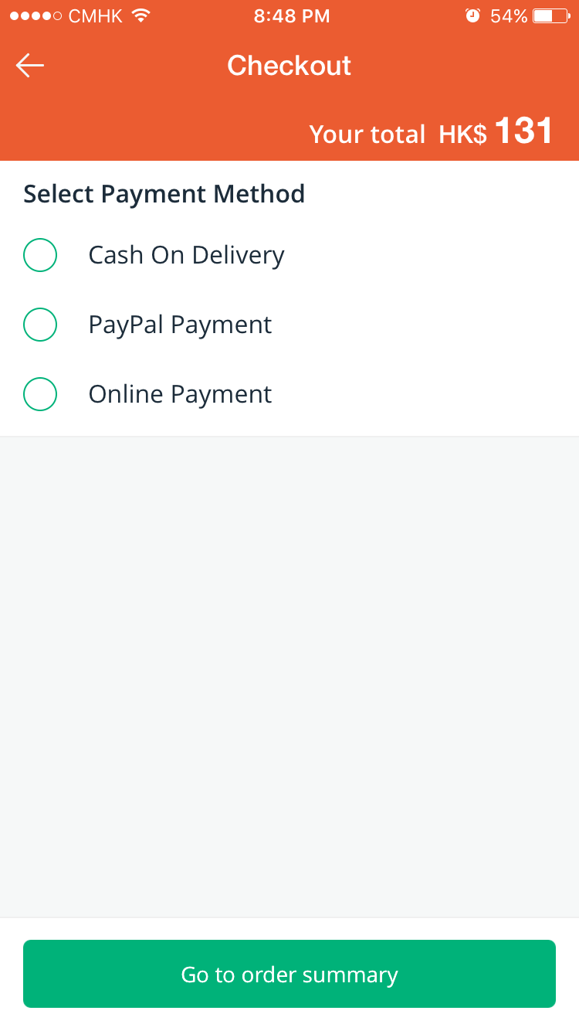

After selecting all the food for ordering, click the basket button on the bottom to access the basket and proceed to checkout. Foodpanda provides 3 kinds of payment methods, “Cash on Delivery”, “PayPal Payment” and “Online Payment”. After placing order, it will then send the request to the restaurant and wait for approval.

After restaurant, had approved the order, the restaurant will start preparing the order and then delivery it to the user.

# Good and Bad

1. Good

foodpanda allows users to change the application language, it provides both Chinese and English version. This function is very useful in Hong Kong since Hong Kong is a multicultural society and it allows user to choose the language they prefer.

In addition, all the important factors about restaurants including the delivery time, the cost and rating is shown on the main page when selecting restaurants for order. It allows user to see all the important factors at first glance.

1. Bad

foodpanda only provide a small image when viewing the menu and it also does not allow user to enlarge the image. If users want to view a larger picture of the food they want to order, they must click on the food which brought them to the detail page of the food and it is not convenient.

foodpanda only show menu for the restaurants which are still opening. When users clicked on a restaurant which is already closed, foodpanda only shows the basic information of the restaurant but not the menu. Therefore, if users want to plan on what restaurant they can order on tomorrow morning, they must visit the restaurant’s web-site instead of viewing the menu in foodpanda.

# UberEats

# Introduction



UberEats is one the expansion product of Uber Technologies, Inc. Uber Technologies, Inc. is worldwide transportation company which allows users to become driver and receive transportations service request and it also allows user to request transportation services from Uber driver. UberEats utilize its existing network and provide online food ordering services and food delivery service. UberEats is available in London, Hong Kong, Tokyo and many other places around the world.

# C:\Users\peter\AppData\Local\Microsoft\Windows\INetCacheContent.Word\IMG_0121.pngC:\Users\peter\AppData\Local\Microsoft\Windows\INetCacheContent.Word\IMG_0161.pngOperation

1. Search

After login to UberEats, it will then ask you for the delivery location. If you allow UberEats to use the GPS of your phone, it will select your current location as the default delivery location. After entering the delivery location, it will bring you to the UberEats main page.

1. Choose

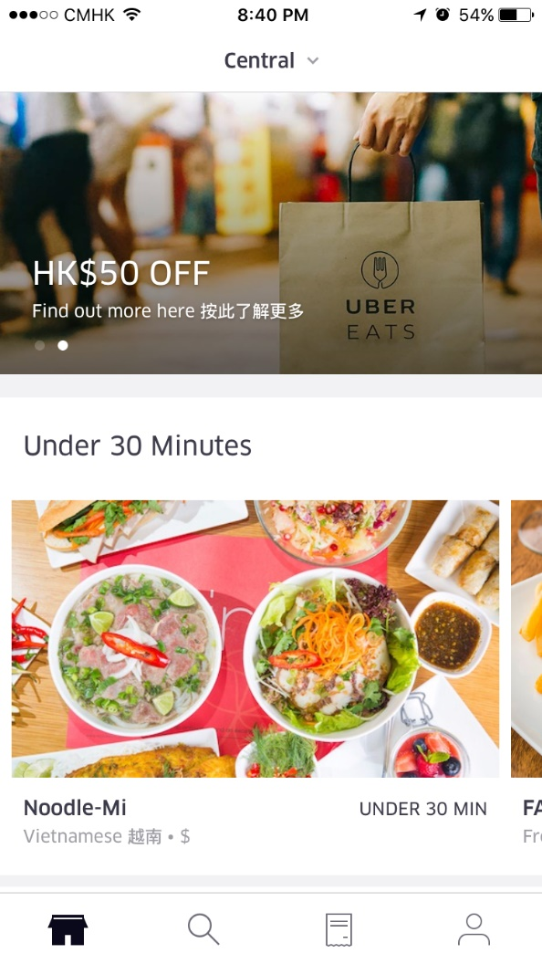 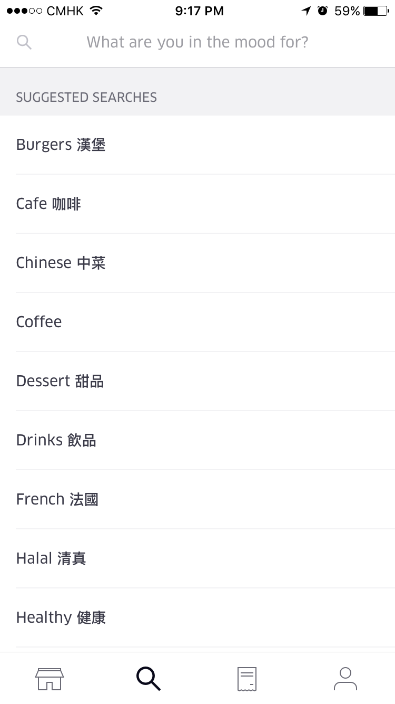

The UberEats main page shows all the available restaurants near the delivery location previously entered. It shows images which represent different restaurant, restaurant name, the type of food which restaurant provide and the delivery time.

UberEats also provide a search function which allow user to search with restaurant’s name or type of food.

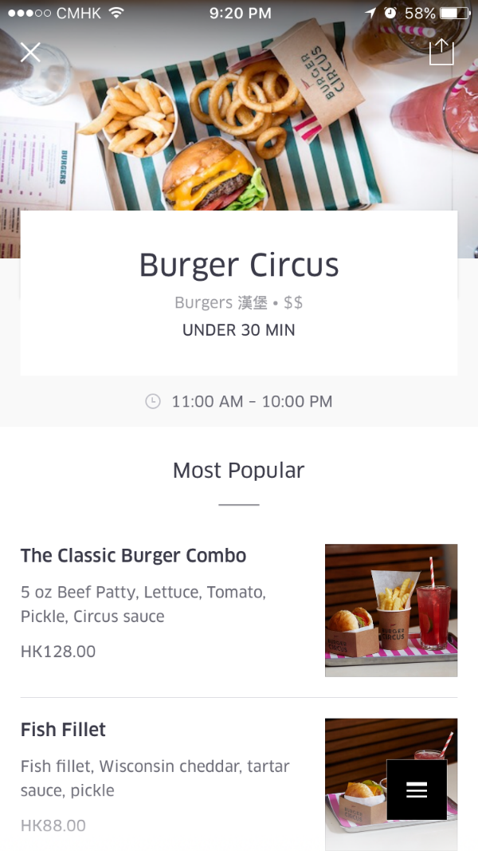 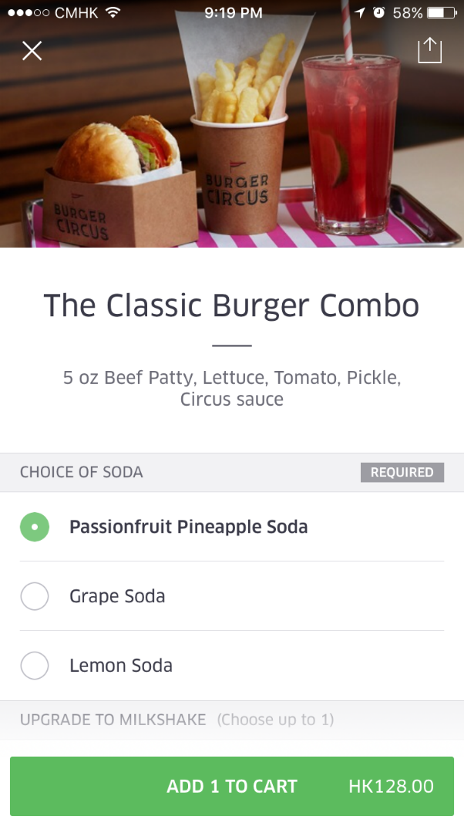

After selecting the restaurant, it shows a list of food which can be ordered. In the list, it shows a small picture of the food, the prices and the name of the food. Some of the restaurant in UberEats can provide a set of food just like the above figure showed. After selecting the food for order, user can add the order to the cart for payment.

1. Payment

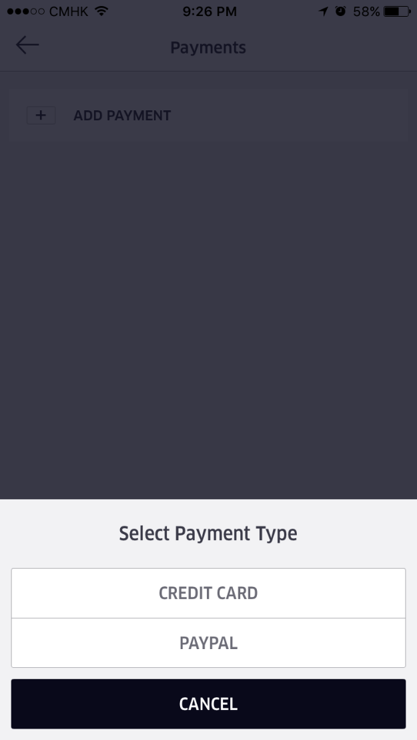 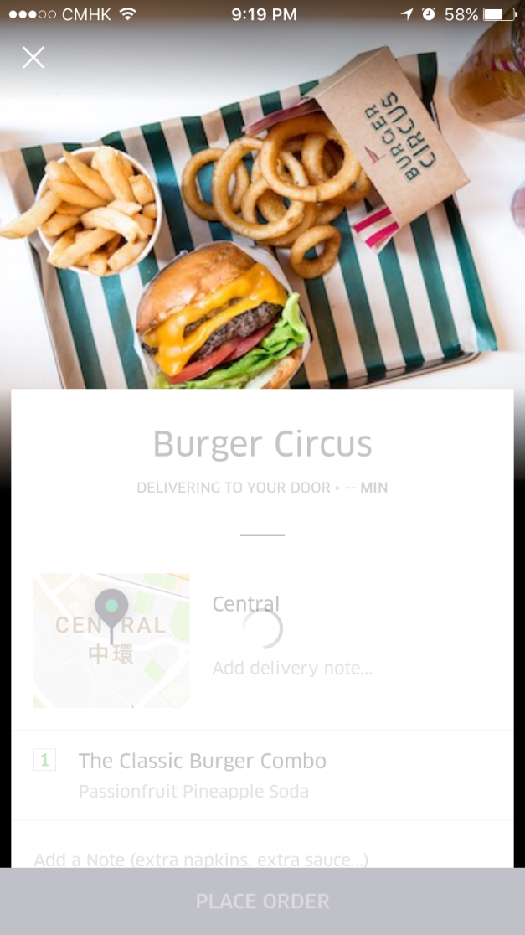

After selecting foods, user can visit the cart and place order. If user had never added a payment method to UberEats before, it will prompt another page for user to add a payment method. UberEats currently allow credit card and PayPal as the payment method. After placing the order, user can monitor the delivery status including remaining time and where the UberEats delivery person is.

# Good and Bad

* + - 1. Good

UberEats provide a user-friendly interface, it is very to use and easy to explore. It also provides function which allow restaurant to provide foods and drinks as a set. It is a very useful function which allow user to quickly order foods and drinks together.

In addition, UberEats also allow user to customize their meals. Therefore, if some users have some kind of allergies to specific kinds of food, they can add some special instructions for the chosen restaurant

UberEats also provide map tracking for food delivery drivers. User can check where the drives is and how much longer they need to wait until the food arrive.

* + - 1. Bad

UberEats does not provide any rating and review system. Reviewing functions is important for food ordering service application because users may want to see how others user thinks before placing orders.

Some of the foods from UberEats do not provide a picture or a description of it. It is very difficult for user to determine what kind of foods is it, what it contains and why user can expect form it.

When there is an error when ordering, it will bring you to the main page of UberEats instead of the cart page. After the error, user need to add items to the charts all over again.

# Development Methodologies Consideration

# Structured systems analysis and design method

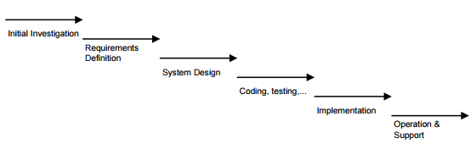

Structured systems analysis and design method is a sequential development process which the project is divided into sequential phases [5]. It put emphasis on planning, time scheduling, budgeting and implementing of an entire system at one time. It also put emphasis on the use of extensive written documentation.

Advantages of SSAD:

* It is ideal for project team with less experience since it is very simple
* Progress of the system development is measurable
* It requires less resources

Disadvantages of SSAD:

* It is inflexible
* It depends on early discover and identify of requirement
* It does not respond to changes very well
* Problems are usually discovered during system testing

# Incremental

C:\Users\peter\AppData\Local\Microsoft\Windows\INetCacheContent.Word\Untitled Diagram (2).png

The incremental development model is the combination of linear and iterative process which a series of waterfalls are performed and each waterfall is performed it order to complete a small part of the system.

Advantage of Incremental:

* It is flexible
* Easy to manage risk
* Concrete evidence can be provided to proof development progress

Disadvantage of Incremental:

* Because some modules of the system may be completed before other modules, a clear interface between different is required.
* Difficult problems tend to be pushed to later iteration.

# Rapid Application Development

C:\Users\peter\AppData\Local\Microsoft\Windows\INetCacheContent.Word\Untitled Diagram (1).png

Rapid application development is an iterative development process which its key principles are produce high-quality system quickly through the use of iterative prototyping, active user involvement, produce documentation necessary to facilitate future development and maintenance and put less emphasis on planning and more emphasis on process [6].

Advantages of RAD:

* It involves user at the early stage of development
* Can produce an incomplete but functional system at the early stage of development
* It helps to easily identify problems and missing functions

Disadvantages of RAD:

* Quick prototyping may result in inflexible system design and a “quick and dirty system”
* Requirement may frequently change

# Methodology Selected

Rapid application development is selected for this project.

Structured systems analysis and design method does not fit this project because it is inflexible and slow due to tight controls and significant structure and depends upon early identification of requirements which problems may not be discovered until the system is finished.

On the other hand, Incremental development model does not have the weakness like waterfall did. However, when utilizing a series of waterfall phases, there is usually a lack of overall consideration of the business problem and well-defined and complete interfaces are required because some modules will be completed before other modules. In addition, incremental development model is not suitable for small projects of short duration,

With the use of rapid application development, the operational version of the system is already available at early stages and it is much earlier than with Waterfall and Incremental. It also concentrates on the important of the system from user viewpoint and provide the ability to rapidly change the system design which lead to saving in time and effort.

# Project Plan

# Project Schedule

|  |  |
| --- | --- |
| **Activities** | **Date** |
| Project Seminar | 26 May 2016 |
| Submission of Initial Project Proposal/Interest Form | 5 Aug 2016 |
| Tentative Assignment of Supervisor and Second Assessor | 12 Sep 2016 |
| Submit Finalized Final Year Project Proposal | 3 Oct 2016 |
| Approval of Project Proposal | 14 Oct 2016 |
| Submit interim report | 3 Dec 2016 |
| End-of-semester interview with second assessors | 23 Dec 2016 - 6 Jan 2017 |
| Submit Draft Report to Supervisor for comment | Mid-February 2017 |
| Final Report | 31 March 2017 |
| Presentations and Demonstrations | 1. April – 5 May 2017 |

# Work Break Down structure

C:\Users\peter\AppData\Local\Microsoft\Windows\INetCacheContent.Word\FYP_WBS.PNG

# Gantt Chart

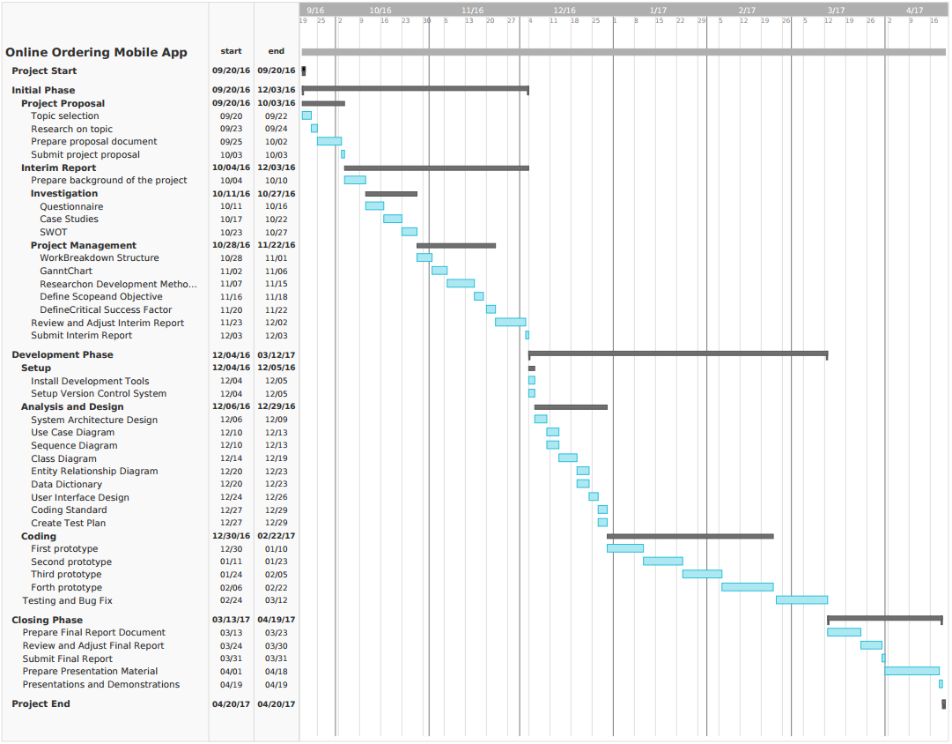

# Project Deliverables

1. Project Management
   1. Project Proposal
   2. Project meeting logs
   3. Project email records
   4. Requirement Specification
2. Development
   1. System Design Specification
   2. Coding Standards and Naming Conventions
   3. Data Dictionary
   4. Final Software Product
   5. Use Case Diagrams
   6. Source Code
3. Other
   1. Test Plan
   2. User Manual
   3. Implementation Plan
   4. Contingency Plan

# Development Tools

1. Operation System
   1. Windows Server 2016
   2. Windows 10
   3. Android 6.0 Marshmallow
2. Database
   1. Microsoft® SQL Server® 2016 Express
3. Development IDE
   1. Visual Studio Community 2015
   2. IntelliJ IDEA Community Edition
   3. Android Studio
4. Diagram Tool
   1. Draw.io
5. Version Control
   1. GitHub Desktop
6. Project Management
   1. Microsoft Project 2016
7. Text Editing
   1. Notepad++
   2. Sublime Text 3
   3. Google Document

# Reference

[1] Google Android Market “OpenRice” [Online].

Available:<https://play.google.com/store/apps/details?id=com.openrice.android&hl=zh_HK> [Accessed: Sep-2016]

[2] Takeaway.com - Order Food

Available: https://play.google.com/store/apps/details?id=uk.takeaway.android&hl=zh\_HK [Accessed: Sep-2016]

[3] FoodPanda

Available: https://play.google.com/store/apps/details?id=com.global.foodpanda.android&hl=zh\_HK [Accessed: Sep-2016]

[4] Jackson, S. E., Joshi, A., & Erhardt, N. L. (2003). Recent research on team and organizational diversity: SWOT analysis and implications. Journal of management, 29(6), 801-830.

[5 ]Ashworth, C., & Goodland, M. (1990). *SSADM: A practical approach*. McGraw-Hill Book Company Limited.

[6] Martin, J. (1991). Rapid application development (Vol. 8). New York: Macmillan.